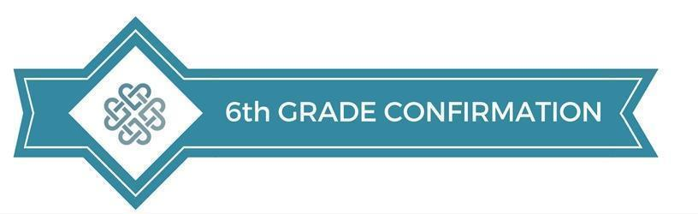
2026 Lesson Schedule

September 13| The Journey

September 20| Bible 101
Students receive a Bible in class

September 25-27|Fall Retreat
*Core Activity for Confirmation*

October 4|God’s Big Story: Creation

October 11| God’s Big Story: The Fall

October 18| God’s Big Story: Redemption and Our Identity in Christ

October 25| Faith Heritage: Judaism and Catholicism

November 1| Faith Heritage: John Wesley

November 8|Faith Heritage: What is the Church?

November 15|What is Worship?

November 22| Thanksgiving Week – No Class

November 29| Thanksgiving Week – No Class

December 6| What is Baptism?

December 13| What is Communion?
*Cross Dedication @12:15pm*

Student Serve and Sunday Night Live
To see our full calendar of Student Serve (family service projects) and Sunday Night Live (fun events), click here to visit our website!

